Store Rating Website - Project Documentation

This document provides detailed information and screenshots of the Store Rating Website project. The project allows users to sign up, log in, rate stores, and manage ratings. It also provides different dashboards for Administrators, Store Owners, and Users.

**Login Page**

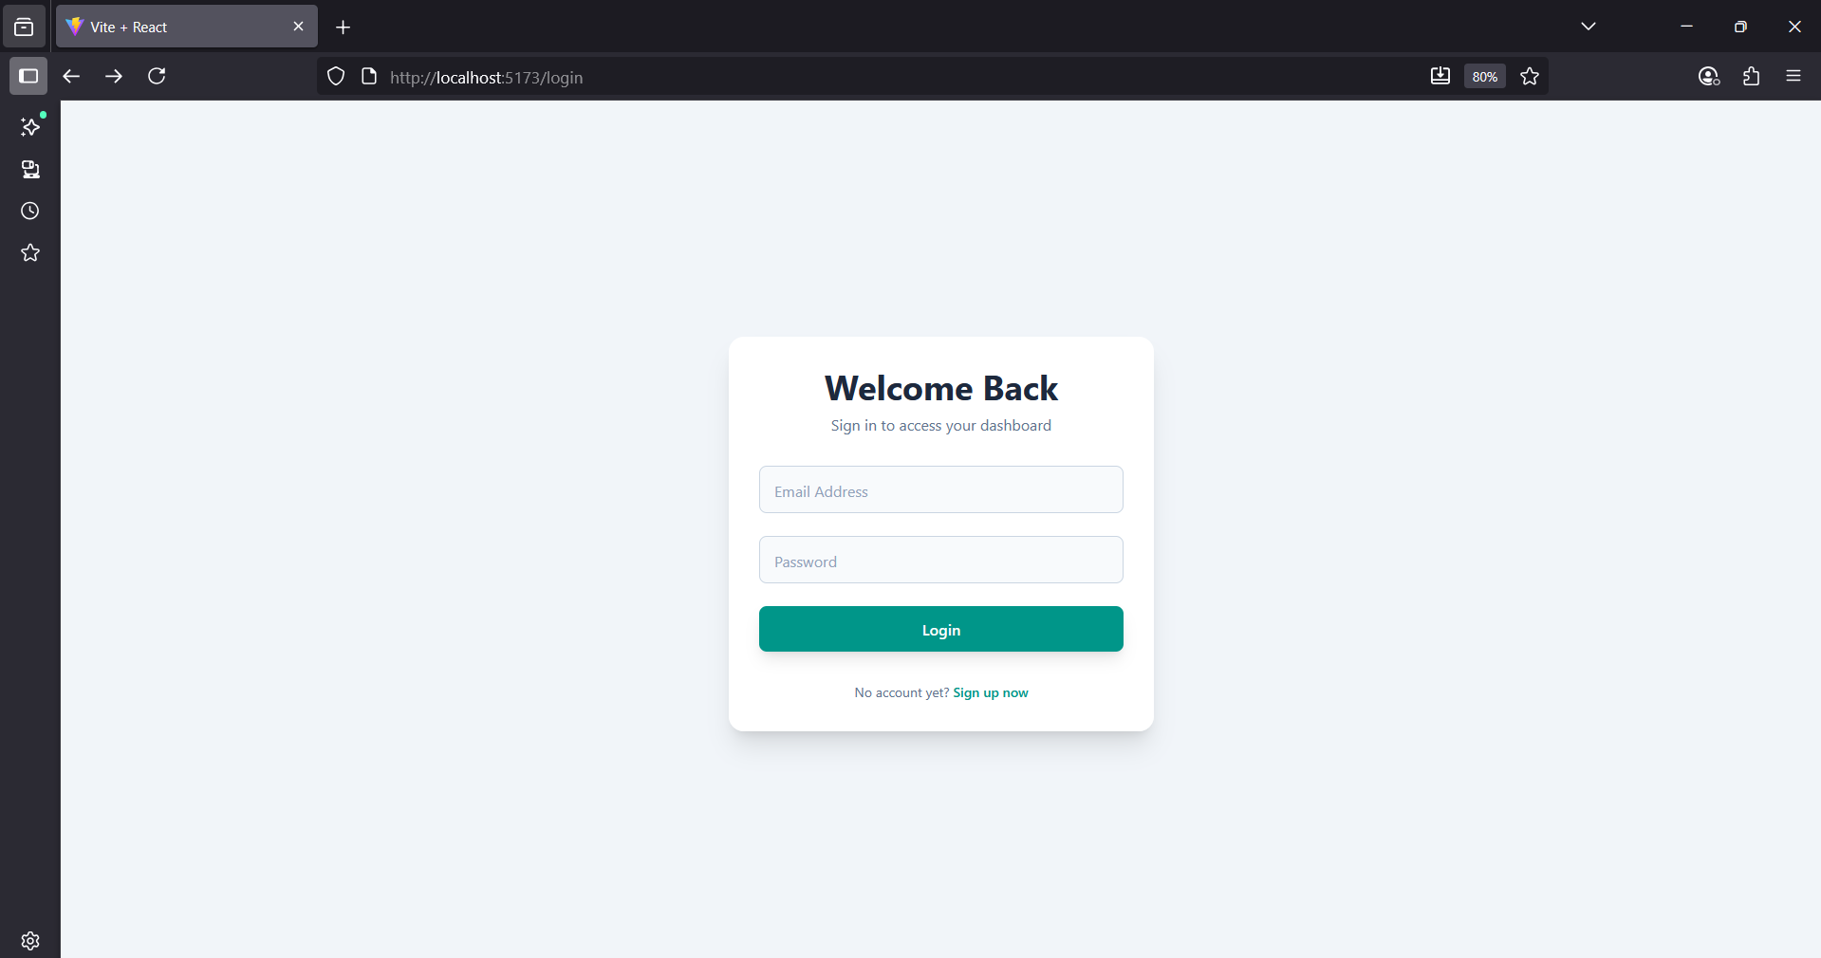

**Sign Up Page**

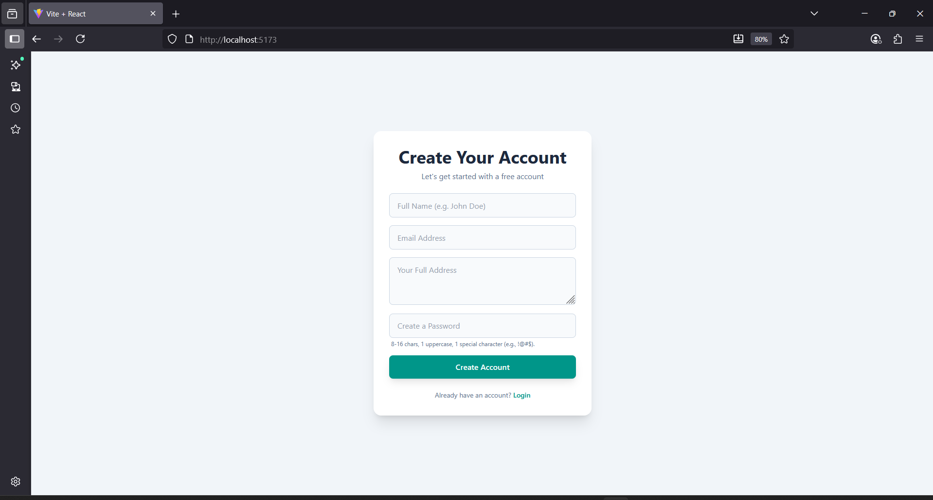

**Administrator Dashboard**

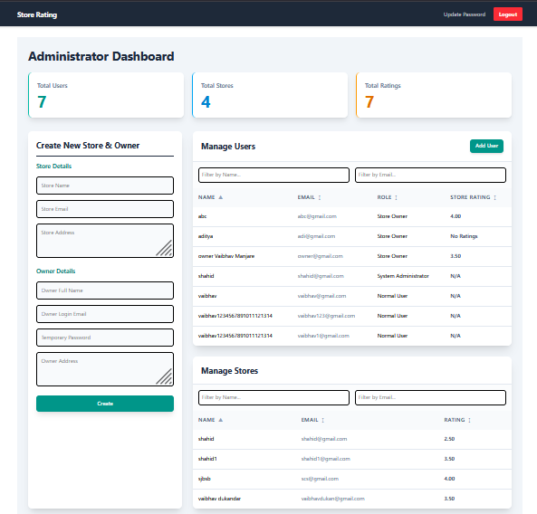**Update Password Page**

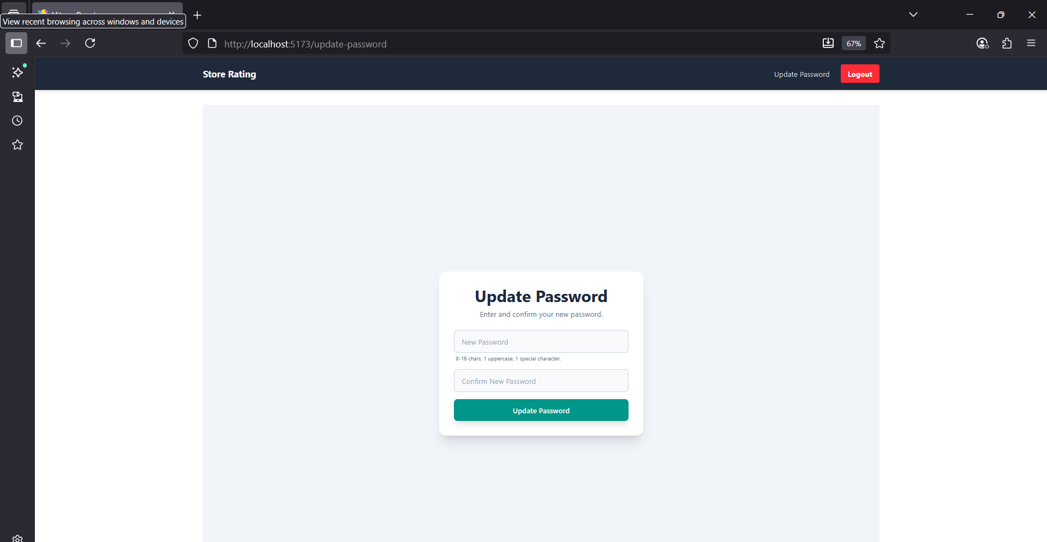

**User Dashboard - Discover Stores**

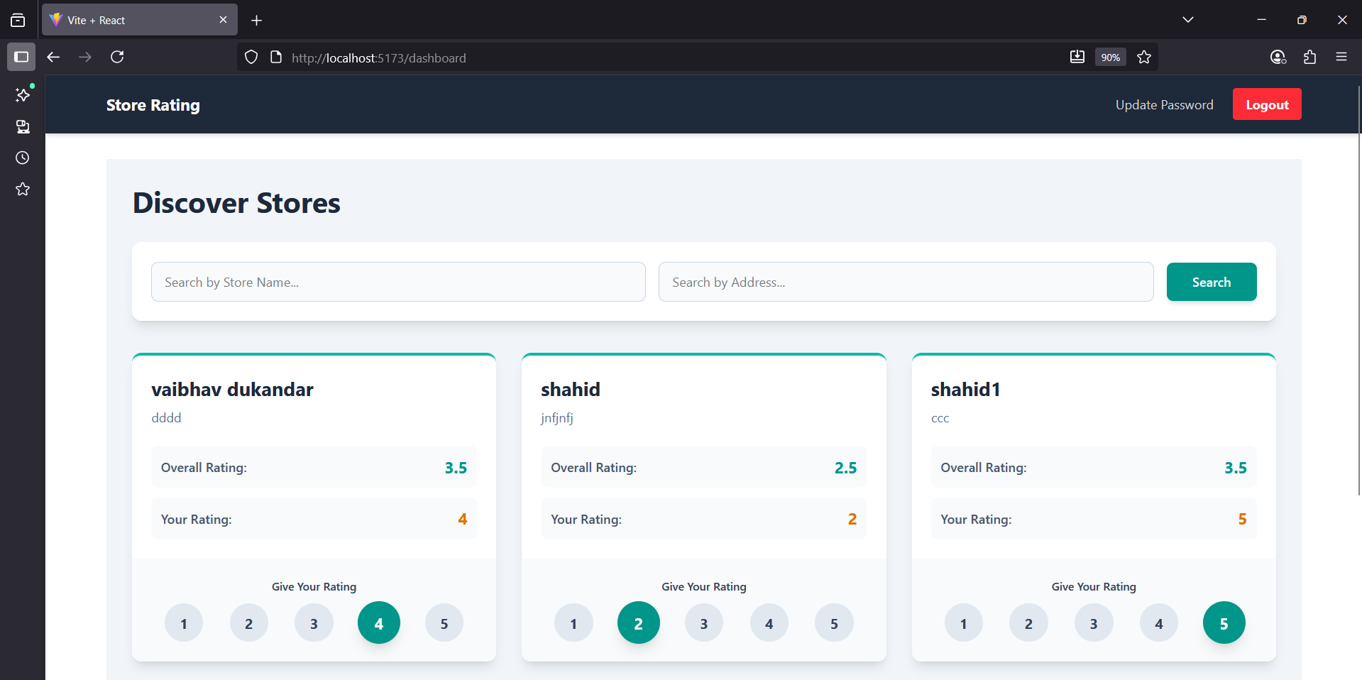**Store Owner Dashboard**

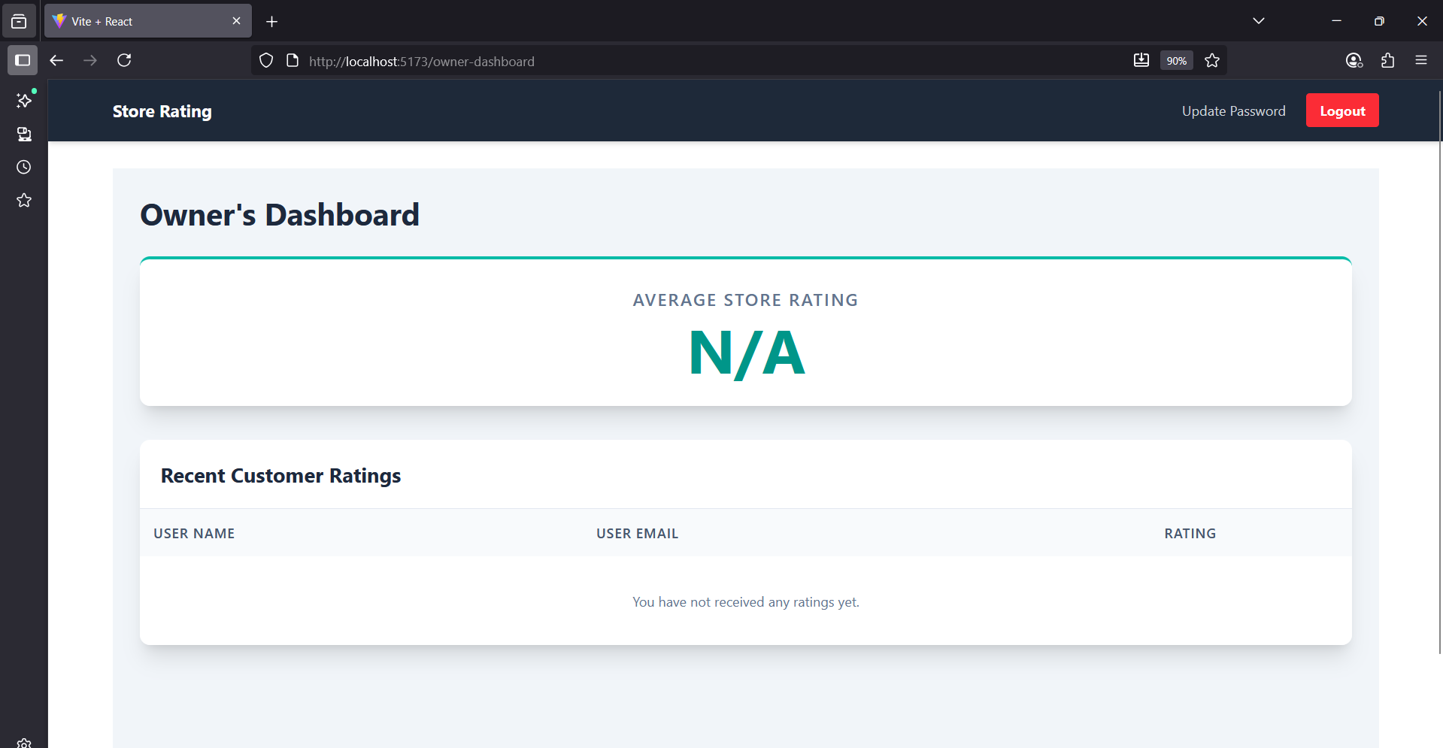

**Add User:**

